The Spirit-Filled Parent
Ephesians 6:4
Categories: Parenting, Spirit-Filled, Ephesians, Christian Living
^{NAS} Ephesians 6:4 And, fathers, do not provoke your children to anger; but bring them up in the discipline and instruction of the Lord.
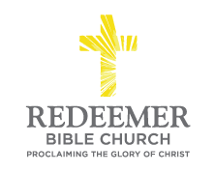
Angelo L. Tolentino / Morning Service / Meeting at The Classical Academy Online High School / Oceanside, CA / July 31, 2016

Intro:
- Preaching Point: God is speaking to you through this passage so you would __________________ ______________________ _______________________.

- Shepherd Your Children in L______________________, 4a

  - Parties involved.

  - Enemies that threaten.

    - P___________________________________

    - E___________________________________

    - Examples of Unloving Shepherding

- Shepherd Your Children in T______________________, 4b

  - World’s Way of Dealing with Children’s Behavioral Issues: M_______________

  - God’s Way of Dealing with Children’s Behavioral Issues: I_________________

    - Means:

      - Discipline

      - Instruction

    - Motivation: “of the Lord”

Conclusion:

